**Exercise-8**

**Question-1:-**

**Output:-**

If we click on calculate it will display a page of result

**Question-2:-**

**Output:-**

If we click on check eligibility it opens a page and there you have to enter the age

Now clicking on ok it will take another page

There you will notice that eligible to drive or not

**Question-3:-**

**Output:-**

If you click on confirm student a new page will open

And next you have to type register number

Now you will receive confirmation of the student with registration number

**Question-4:-**

**Output:-**

If you click on calculate cost it will appear new page In that page you have to enter the cost of the material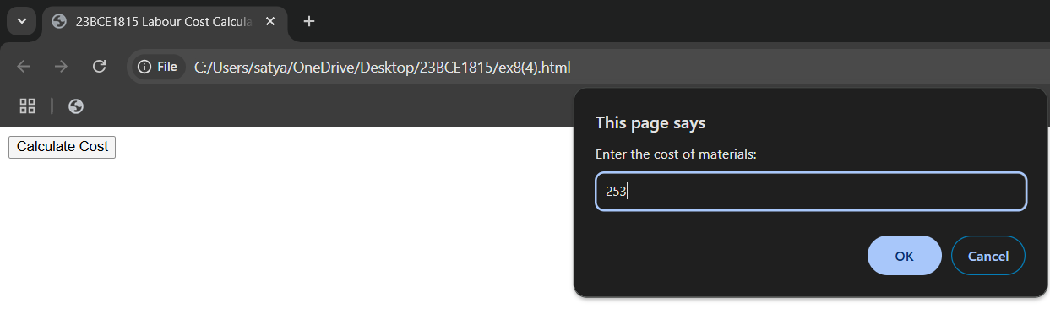

After clicking on ok you will see the labour cost and the total charge in the new page

**Question-5:-**

**Output:-**

Here it will display registration number and name

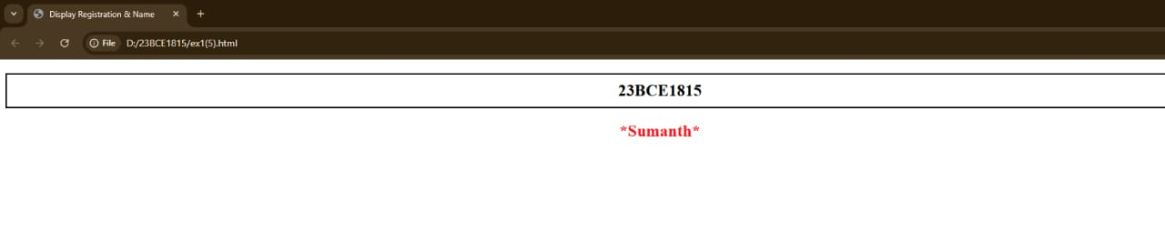

**Question-6:-**

**Output:-**

Here it will display total amount of the circus ticket booth

